Classification of Urban Canopy Cover with LiDAR and Multispectral Data

Background

The presence of trees can enhance the human, environmental, and ecological health in urban environments. Having access to accurate and up-to-date canopy cover maps is important for supporting sustainable urban planning. LiDAR point clouds have been used for automated classification of buildings and trees, but this approach is somewhat limited in terms of distinguishing between trees and non-tree land cover types. Satellite imagery, such as the data obtained from Sentinel-2, can provide multispectral information that can be used to analyze vegetation and other land cover types (Ebadat et al., 2016). A machine learning classifier known as “Random Forest'' has gained popularity as a technique used for automated classification of land cover (Belgiu & Dragut, 2016). Random Forest is an ensemble classifier, where an ensemble classifier is defined as a “learning algorithm that constructs a set of classifiers and then classifies new data points by taking a weighted vote of their predictions” (Dietterich, 2000). Combining LiDAR data with Multispectral data can give us a large selection of variables that can be used for classification with a Random Forest approach (Ebadat et al., 2016).

Project Objectives

The goal of this project was to extract data from LiDAR and from Sentinel-2 multispectral imagery, and to use these data as “predictor variables” in a random forest classifier to classify tree and non-tree land cover. The project area was the Irvington Historic District neighborhood in Indianapolis, Indiana. See Figure 1 below for an overview of the project methods. Figures 2 and 3 below show the Irvington Historic District project area.

Methods

To train the classifier, reference data were collected using Collect Earth Online (CEO). The reference data consisted of 245 total plots, each 10 m in width. Each plot had multiple samples that consisted of points and polygons, which resulted in 542 total samples. Each sample contained a binary classification of “tree” and “non-tree” land cover type. This data was then exported as a CSV file and uploaded as an asset in Google Earth Engine (GEE).

LiDAR variables included slope, aspect, Canopy Height Model (CHM), and Digital Elevation Model (DEM). LiDAR point cloud data were retrieved from USGS to extract slope and aspect. The CHM and DEM were obtained from the Indiana Geographic Information Council. LiDAR data was processed using CloudCompare and QGIS, and each variable was then uploaded as an asset in GEE.

Sentinel-2 variables included the Normalized Difference Vegetation Index (NDVI), Enhanced Vegetation Index (EVI), Leaf Area Index (LAI), Normalized Difference Water Index (NDWI), Normalized Difference Moisture Index (NDMI), Normalized Difference Built-up Index (NDBI), and an RGB composite consisting of bands 2, 3, and 4. These variables were extracted in Google Earth Engine and saved as assets. All LiDAR and Sentinel variables were merged into a multiband image in GEE, where each individual band contained one of the variables (i.e. NDVI = B1, EVI = B2, etc.). Figures 4, 5 and 6 show the code used for analysis in GEE. Figure 7 below shows a visual example of some of the LiDAR and Sentinel variables.

Results

The classifier was trained using the reference data and was then applied to the predictor variables in the multiband image to classify the land cover as “tree” and “non-tree”. An accuracy assessment was performed to evaluate training data, validation data, confusion matrix, user accuracy, and producer accuracy. The overall training accuracy was 0.96, overall validation accuracy was 0.88, and user accuracy was 0.88. For producer accuracy, the non-tree class had an accuracy of 0.72, and the tree class had an accuracy of 0.97.
See Figure 8 below for the results of the classified map and see Figure 9 for Google satellite imagery for comparison. See Figures 10 and 11 for a zoomed in comparison of the classified map and the satellite imagery. For the graphic containing the confusion matrix, validation error matrix, and resubstitution error matrix results, see Figures 12-19.

Discussion

The classifier appeared to do well at identifying tree cover with a 97% accuracy, but not as well at identifying non-tree cover with a 72% accuracy. To summarize, 97% of the time, the classifier predicted the presence of a tree in a location where the validation data agreed with the classification, but 3% of the time the validation data disagreed and indicated that the land cover should be “non-tree” instead of “tree”. Additionally, 72% of the time the classifier predicted the presence of “non-tree” land cover at a location where the validation data agreed, but 28% of the time the validation data disagreed and indicated that the land cover should be “tree” instead of “non-tree”. The overall accuracy of the classified image is around 88.6%. This is a reasonably accurate starting point which could be improved upon further with future research.

To improve upon this project, I would recollect the training data, ensuring that the most statistically sound sample design is being used. I would also collect more training data, ideally having 1,000 or more reference points. Additionally, I would compare the results from using different combinations of variables. It is possible that some of the current variables are redundant or are not informing the classifier as expected, though I do feel that each of the variables chosen are important and informative.

Through this project (and some of the troubleshooting and project exploration), I have gained programming practice using JavaScript, Python, and excel. I have learned about LiDAR data sources and how to locate, download, process, and analyze LiDAR data. I have also learned about the Sentinel-2 program and the large selection of spectral bands and high spatial resolution it can offer. Additionally, I learned about the statistical/machine learning approach of random forest classification, and practiced methods of evaluating the accuracy and validity of project data and results.

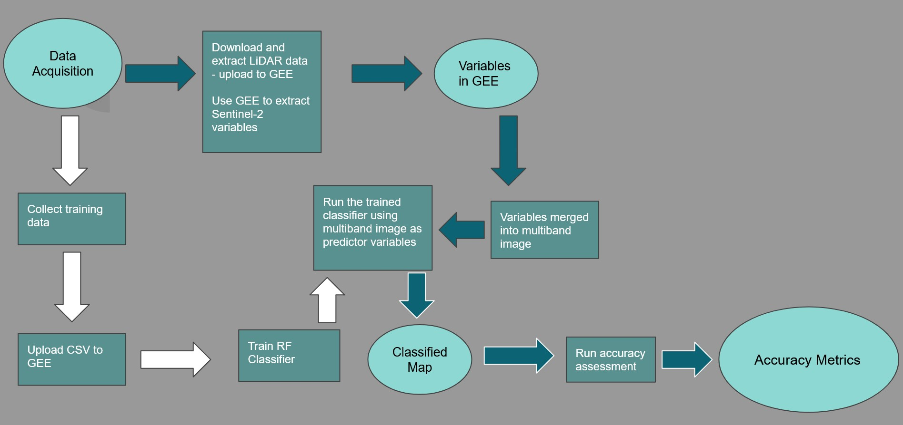
Figure 1 above shows a flowchart of the project methodology.

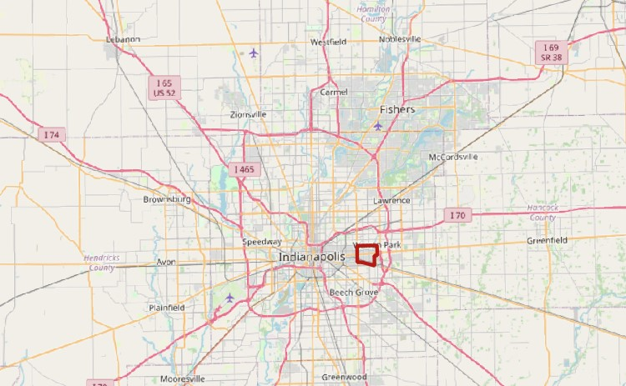

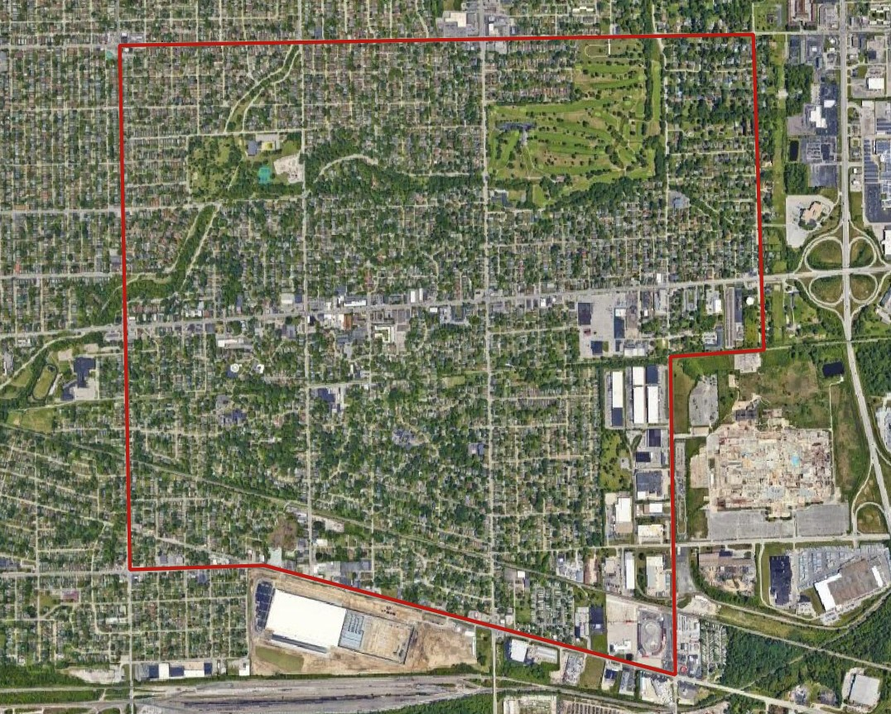
Figures 2 and 3 above show the project area of the Irvington Historic District in Indianapolis, Indiana.
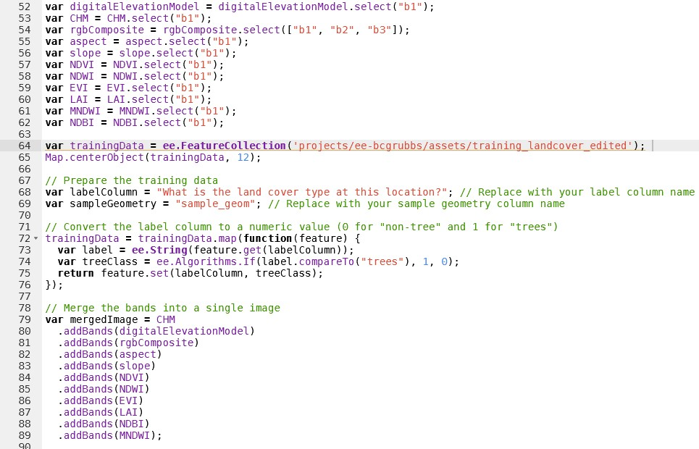
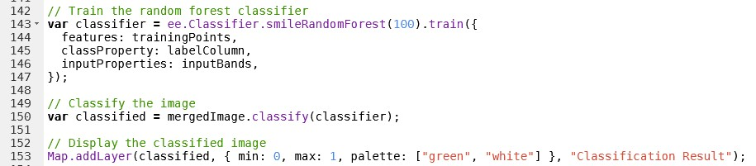
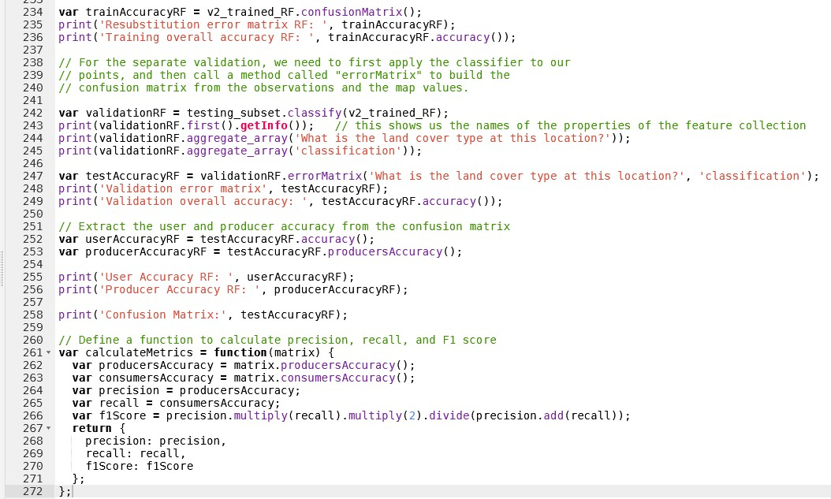
Figures 4, 5, and 6 above show the JavaScript code used in GEE to load the variables, combine the variables into a multiband image, prepare the training data, train the classifier, classify the image, display the classified image, then calculate the accuracy assessment metrics.
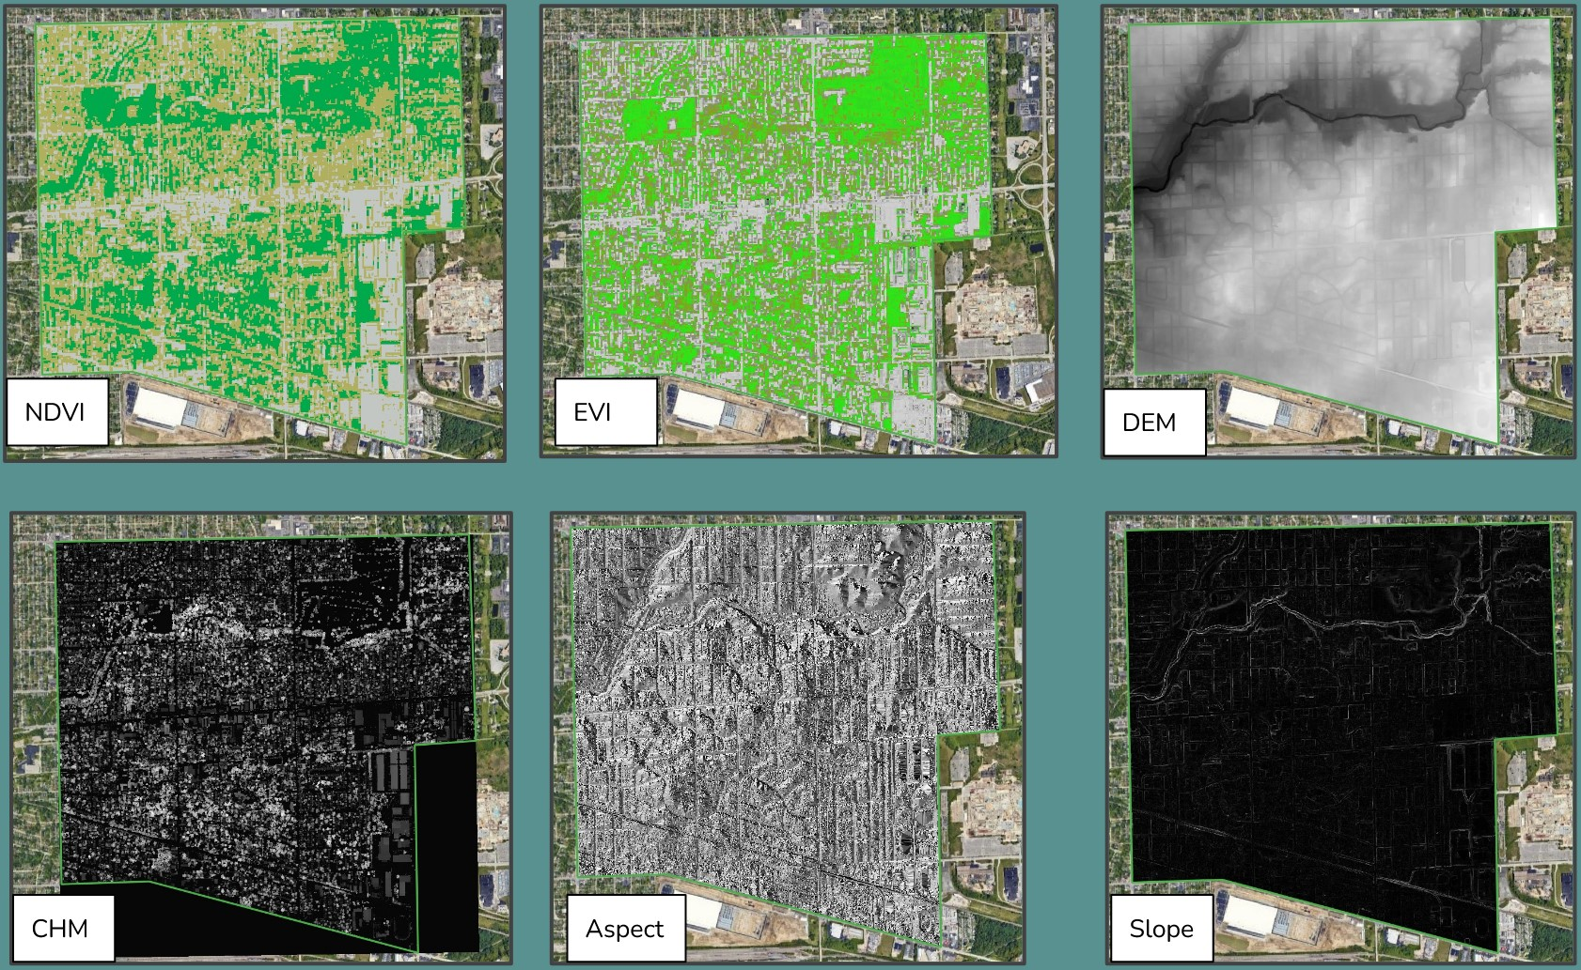
Figure 7 above displays NDVI, EVI, DEM, CHM, aspect, and slope within the project area.

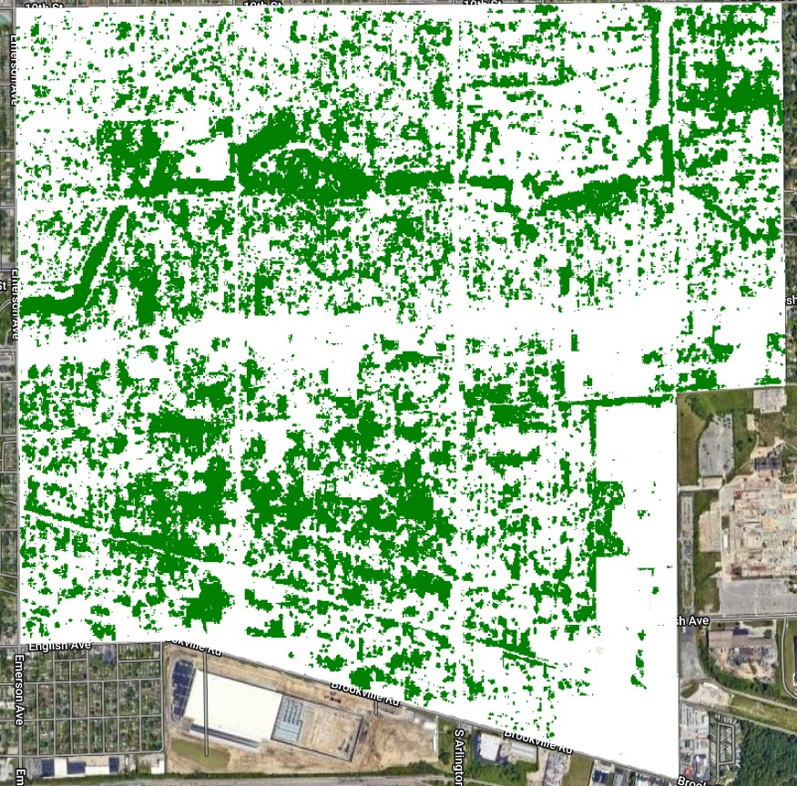
Figure 8 above shows the final classified image showing tree cover in green and non-tree cover in white.


Figure 9 above shows the Google satellite imagery for the project area for comparison.
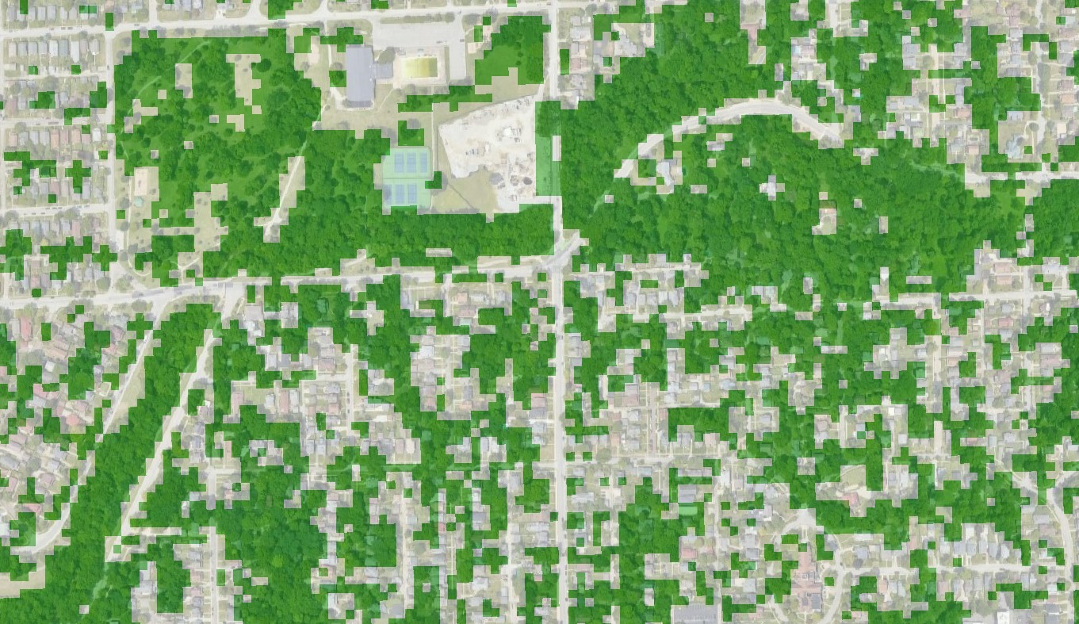

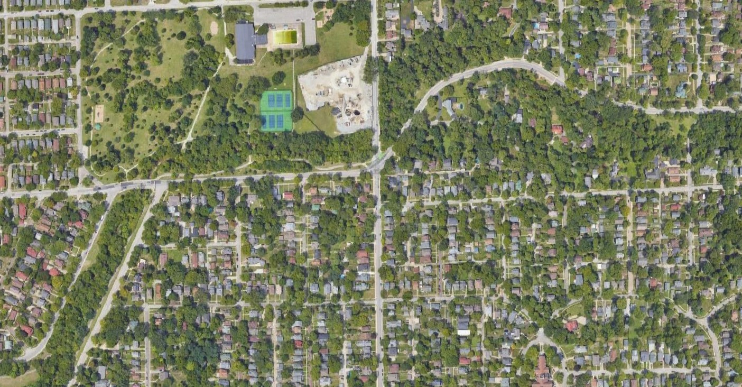
Figures 10 and 11 above show the classified image zoomed in with a transparency of 50% compared with the same area zoomed in on Google satellite imagery.

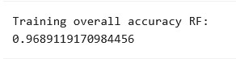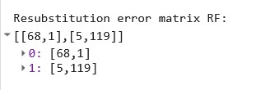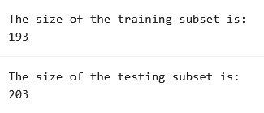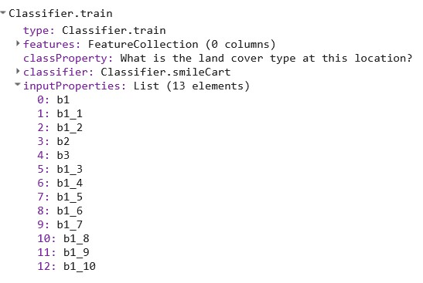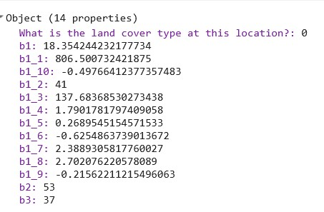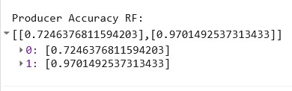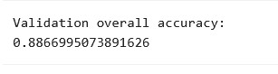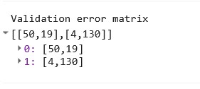

Figures 12-19 above show the accuracy metrics results for this project.

References
Belgiu, M., & Dragut, L. (2016). Random forest in remote sensing: A review of applications and future directions. ISPRS Journal of Photogrammetry and Remote Sensing. https://www.sciencedirect.com/science/article/abs/pii/S0924271616000265?via%3Dihub

Dietterich, T. (2000). nsemble Metho ds in Machine Learning. Oregon State University Corvallis Oregon US. https://link.springer.com/chapter/10.1007/3-540-45014-9_1

Ebadat, P., Amati, M., & Fraser, C. (2016). MAPPING URBAN TREE CANOPY COVER USING FUSED AIRBORNE LIDAR AND SATELLITE IMAGERY DATA. ISPRS Annals of the Photogrammetry. https://www.researchgate.net/profile/Ebadat-Ghanbari-Parmehr/publication/307530163_MAPPING_URBAN_TREE_CANOPY_COVER_USING_FUSED_AIRBORNE_LIDAR_AND_SATELLITE_IMAGERY_DATA/links/57d9d7b908ae0c0081efbeb1/MAPPING-URBAN-TREE-CANOPY-COVER-USING-FUSED-AIRBORNE-LID

Li, X., Chen, W., Sanesi, G., & Lafortezza, R. (2019). Remote Sensing in Urban Forestry: Recent Applications and Future Directions. remote sensing. www.mdpi.com/journal/remotesensing

Speiser, J., Miller, M., Tooze, J., & Ip, E. (2019). A comparison of random forest variable selection methods for classification prediction modeling. Expert Systems With Applications. https://www.sciencedirect.com/science/article/abs/pii/S0957417419303574?via%3Dihub

Wai, Y., Ahmed, S., & El-Ashmawy, N. (2015). Urban land cover classification using airborne LiDAR data: A review. Remote Sensing of Environment. https://www.sciencedirect.com/science/article/pii/S0034425714004374?via%3Dihub

Zhang, C., Zhou, Y., & Qiu, F. (2015). Individual Tree Segmentation from LiDAR Point Clouds for Urban Forest Inventory. remote sensing. www.mdpi.com/journal/remotesensing

